Shabbos Stories for
Parshas Emor 5774
Volume 5, Issue 36 3 Iyar 5774/ May 3, 2014
For a free subscription, please forward your request to keren18@juno.com

Weekly Chasidic Story #856
The Secret Recipient
From the desk of Yerachmiel Tilles
editor@ascentofsafed.com

Rabbi Chayim Halberstam of Sanz, known as the Divrei Chayim, was deeply involved in the mitzvah of tzedaka (charity), giving with an open hand from his own funds and soliciting from others as well. In keeping with the rabbinical dictum that charity collectors should travel in pairs, he always went on his rounds with a respected member of the community.

Collecting for a Wealthy Man
Who Had Gone Bankrupt
One time Rabbi Chayim set about to collect a large amount of tzedaka for a certain wealthy man who had gone bankrupt. He and a trusted companion went about from house to house soliciting funds, when they came to the elegant home of one of the richest men in the city.
They entered the beautifully appointed anteroom and were shown to a velvet sofa where they were served tea from a silver tea service while they waited for the master of the house to appear. After a few minutes a well-dressed gentleman entered and greeted the illustrious Rabbi warmly.
The Rabbi and his companion requested that the wealthy man donate the large amount of five hundred rubles for an unspecified "worthy cause."
The rich man considered their request for a few moments and then asked, "Tell me, exactly what is the cause you're collecting for? Is it for some public institution or for a private person?"
Rabbi Chayim replied that he was collecting for a wealthy citizen who had lost all his money and gone into bankruptcy. But this answer wasn't sufficient for the man, and he began to inquire further about the identity of the person.

Refuses to Divulge the Man’s Name
"I'm sorry," replied Rabbi Chayim, "but I cannot divulge the man's name, since that would cause him terrible embarrassment. You'll just have to trust me when I tell you that he's a very deserving individual."
The rich man refused to be dissuaded from his curious pursuit of the man's identity. "Of course, I trust you implicitly, and I would be only too happy to donate even several thousand rubles to help you, but I would first like to know for whom I'm giving the money."
At this point the man who was accompanying the Rabbi interjected his opinion that perhaps it wouldn't be so bad to divulge the man's identity in this case. Certainly the rich donor wouldn't allow the information to leave the room, and it was a wonderful opportunity to amass the large amount of money to help a fellow Jew rebuild his life.

Again Refuses to Publicize the Name
But Rabbi Chayim would say only that the man had up until recently been one of the pillars of the community and had himself contributed to many worthy causes before his unfortunate business collapse. Again he protested that he couldn't and wouldn't publicize the man's name.
The rich man, far from being silenced, was even more aroused in his curiosity. "If you tell me his name I will give you half of the entire amount you need."
His fellow collector again tried to convince the Rabbi to tell the man's name, in view of the tremendous sum of money involved, but to no avail.
"You must understand," he replied, "that even though the sum you are offering is more than generous, the honor of this Jew is more important and valuable to me than any amount of money! If you were to give me the total sum that I require, I would still refuse to reveal the identity of the recipient!"
The rich man's countenance changed suddenly and he became very still. He quietly asked Reb Chayim to step into an adjacent room, for he wished to speak with him privately.
Standing alone with the Rabbi, the rich man broke down into bitter sobbing. "Rebbe," he began, "I, too, have lost my entire fortune and am about to enter into bankruptcy. I was too embarrassed to tell this to anyone, but when I saw how scrupulously you guarded the other man's privacy I knew I could trust you. Please forgive me for testing you in such an outrageous manner, but I am a desperate man. I needed to know for sure that under no circumstances would you tell anyone about my terrible situation. I am in debt for such a huge sum, I have no hope at all of repaying it. I'm afraid that I will have no choice but to leave my family and go begging from door to door!"

Returns with a Large Sum of Money
The Sanzer Rav left the home of the rich man, and needless to say, not a soul ever heard a word of their conversation. Less than a week later he returned to the same man's house with a large sum of money. He had been able to raise enough money to rescue not only the original intended recipient, but this one as well. They were both able to pay off their debts and resume their businesses successfully.
The role of the saintly Sanzer Rav in this affair became known only many years later, after he left this earthly world.
Source: Adapted/Supplemented by Yerachmiel Tilles from the rendition in //lChayimweekly.org (#872), with permission.
Connections: 1) Weekly reading-acting in a loving manner towards your fellow Jew (Lev. 19:18). 2) Seasonal-138th yahrzeit of the Divrei Chayim.
Biographic note: Rabbi Chayim Halberstam of Sanz [of blessed memory: 25 Nissan 5553 - 25 Nissan 5636 (April 1793-April 1876 C.E.)] was the first Rebbe of the Sanz-Klausenberg dynasty. He is famous for his extraordinary dedication to the mitzvah of tzedaka and also as a renowned Torah scholar; his voluminous and wide-ranging writings were all published under the title Divrei Chayim.

Reprinted from this week’s email of KabbalaOnline.org, a project of Ascent of Safed
www.ascentofsafed.com ascent@ascentsafed.com

Maybe Hashem Will Help
You Complete the Count
By Rabbi Reuven Semah

“You shall count for yourselves from the day after Shabbat, seven complete weeks.” (Vayikra 23:15)

During the Pesah holiday in our shul we had a class on the halachot of counting the Omer. One interesting question that we discussed was, what if a man must undergo surgery and the surgeon says between the surgery and recovery he will probably be unconscious and will not be able to count the Omer that day. Should he count with a berachah up until the surgery knowing he will miss a day? With that question, one member of our congregation asked, what if someone is terminally ill; can he count with a berachah since he might pass away during the Omer?

Answered by the Following Story
These questions can be answered with the following story told over by Rabbi Ephraim Nissenbaum. Rabbi Yitzchak Zilberman of Bnei Brak was once approached by a man who was deathly ill. The man wanted to know if he could recite the berachah on the counting of the Omer, knowing full well that he would not live to complete counting the whole seven week cycle.
Rav Zilberman told him a parable about a child who wanted a piece of candy, but his parents refused to give it to him. The child recited the blessing and the parents were
forced to give the child the candy to prevent the blessing from being invalid.
Similarly, the man should recite the blessing upon the counting and perhaps Hashem would allow him to complete the counting. Indeed, he recited the daily blessing and died shortly after Shabuot, finishing the whole seven weeks. A person must always think positively.
So to answer both questions we can say, let him count with a berachah and perhaps Hashem will allow the surgery and the recovery to be finished more quickly, which will allow him to count without missing a day, and the terminal patient perhaps will live the entire seven weeks.

Reprinted from this week’s email of the Jersey Shore Torah Bulletin
The Internationally-Acclaimed Chazzan Who Saves Lives on His Motorcycle
By Anav Silverman

Chazon Shlomo Glick on a call to
help save lives in Yerushalayim

They are a familiar site in Yerushalayim and across Israel - United Hatzalah volunteers rushing in their orange vests and red motorcycles to save lives during calls of emergency distress. Each of the 2,100 registered volunteers which include secular Israelis, Ultra-Orthodox, Arabs, settlers, and citizens across the spectrum, carry a defibrillator and necessary medical equipment to treat patients as quickly as possible.

Israeli Cantor Shlomo Glick of Jerusalem
But many volunteers also carry their own stories, leaving behind families, professions and busy lives when the dispatch call arrives. Internationally renowned Israeli cantor, Shlomo Glick of Jerusalem is one of those volunteers. When Glick is not on stage performing with the Israeli Philharmonic Orchestra or singing before international audiences in Berlin, London, New York, and Prague, he is on lifesaving his ambucycle responding to emergency calls in Israel.
The 36-year-old father of six children, who recently performed at the United Hatzalah 10th anniversary concert with other leading chazanim, sat with Tazpit News Agency in an interview about his work as a cantor and an emergency volunteer.
“Haatzalah is always on my mind - I can get a call anywhere and anytime, even in the middle of leading prayer services at the synagogue or recording a cantorial piece at a music studio,” Glick said.

Chazon Shlomo Glick in concert

Chazzan Glick recalls one incident when he was recording a cantorial piece at a well-known music studio in Meah She’arim. “In the middle of the song, my mobile-alert goes off. I rushed to a playground nearby, where a mom had called and treated her unconscious baby.”

Utilizing Unique GPS Dispatch Technology
United Hatzalah utilizes unique GPS dispatch technology to identify the closest and most qualified volunteers to respond to an emergency. This gives volunteers, whose cellphones and motorcycles carry the GPS technology, the ability to arrive on scene between two to three minutes. Glick responds on average to two-three emergency calls every day.
“This Passover, we took our kids on a trip to northern Israel. On the way, I saw a car accident and had to go treat an injured person. My kids know that I have to respond because that’s what dad does,” he explains.
“It’s not easy on the wife and kids - many times I will have to go out in the middle of Kiddush on Shabbat or when putting my children to bed. But one moment can make all the difference when it comes to saving a life,” he told Tazpit News Agency.

Goal is to Prevent Untimely Deaths
“United Hatzalah’s goal is to prevent untimely deaths. We don’t want to say - had we been there, it could have been different,” says Eli Beer, the founder and President of United Hatzalah whose volunteers arrive on scene in less than 3 minutes, filling the time gap between the emergency and the arrival of the ambulance. “Whoever saves a single life, saves an entire world,” he adds, quoting a famous Talmudic adage.
Beer and Glick both believe that their desire to save lives developed from the way they were raised.
“It’s all about education from home - you teach your kids the value of life and that seed grows,” says Beer, a property developer and full-time United Hatzalah volunteer with over 25 years of life-saving experience. Beer was raised in a home where medical volunteering was part of the household. His father was an ambulance driver during the Yom Kippur War and as a young child, Beer witnessed a bus bombing in Jerusalem during the first Intifada and has been on site as medical responder during multiple suicide bombings during the Second Intifadah.

Volunteering is a Family Affair
Like Beer, Glick also grew up with a father who volunteered as an emergency medical responder and says that volunteering is a family affair. “My father, 61, still volunteers as an ambulance driver with Hatzalah and so does my brother,” he explains.
“Our volunteers could just go home after work and play golf,” says Beer. “But they don’t. There’s an understanding that there is more to life than just your livelihood and personal gain.”
Glick himself is well-known in the cantorial world. “Sometimes it shocks people to see that Shlomo Glick is the one responding to their call. They’ve seen him in these powerful performances, belting impressive pieces; they listen to his discs, and suddenly he’s in person treating their condition,” says Beer.
“It would be like Bono arriving on a motorcycle to save people on a weekly basis.”
Glick has even found himself singing to a patient while giving him oxygen. “In one incident, as I was treating an elderly man, his wife had asked me to sing her husband’s favorite cantorial piece and that’s what I did. After, he was treated and discharged from the hospital, he couldn’t believe that it was me who had responded first to the call.”
“Some people have said to me that it’s not fitting for someone of my profession to ride a motorcycle and answer the masses. An artist is supposed to distance himself from the public for his image. But that doesn’t interest me,” explains Cantor Glick. “God gave us life and He can take away life. Your image as a musician or whatever profession, isn’t important when you’re saving a human being’s life.”

Reprinted from the April 27, 2014 website of Matzav.com Printed from the Tazpit News Agency in Israel.

Tales of the Gaonim

The Power of Truth
By Rabbi Sholom Klass

Rabi Pinchas of Koretz was a ﬁrm believer in never uttering an untrue word. He would point to the words of Reb Yehuda Hachasid who stated in Sefer Chassidim (Chapter 47): “He who speaks only truth and never even thinks of falsity will be rewarded by having all his wishes fulﬁlled.”
Rabi Pinchas’ piety and honesty were known far and wide. He would often say, “Even though our Sages (Yevamot 65b) declared that to preserve the peace, a person may change his words to ﬁt the situation, I will never utter a false word regardless of the consequences.” If he heard that one of his followers had uttered a false word, he would expel him from his presence.
One day he met Rav Dov Ber, the Maggid of Mezeritch, who had a tremendous following. Rabi Pinchas asked him, “Why do you have such a large following, whereas I have so few?”
The Maggid answered, “Do you know why parshiyos Chukas, Balak, Maatos and Maasai are often combined, while Parshas Pinchas is always singular? Because Pinchas was a zealot, always seeking the truth and it stands to reason that very few people would be attracted to him.”
The Oath Of A Saint
There was once a rich chasid who would visit the old Rebbe of Shipula who was known as the Saba of Shipula. The man would always ask the Rebbe to daven on his behalf, that he and his family have a child. The Rebbe would never answer him.
One day, while the Rebbe was occupied with communal affairs, the man entered and again pleaded that the Rebbe pray for him.
“Please leave me alone now,” said the Rebbe. “I have important community matters to take care of. Come back another time.”
But the man would not be put off and said, “I am sorry but I will not budge from this place until you promise that you will pray that my wife give birth to a child.”
The Rebbe became angry and exclaimed, “Because you are pushing your luck and bothering me, I swear that you will never have a child! You will always be childless.”
The man was shocked and left the Rebbe with a bitter heart. He vowed never to visit the Rebbe again.

Travels to Koretz on Business
Some time later, the man had the occasion to travel to Koretz on business matters. He entered the beit midrash of Rabi Pinchas where he was giving a shiur.
When the Rebbe completed his learning he walked over and greeted the man. Now, Rabi Pinchas was a poor man and he barely earned enough money to feed his family. Many a day there was no food in the house, and they would go hungry.
Greeting the man, Rabi Pinchas invited him to his home, pointing out that the meal would be slim. In the Rebbe’s home the rich man saw the poverty and deprivation that they were forced to endure. Calling the rebbetzin aside, he said to her, “I would like to be your guest for Pesach. Your husband is a holy man and I would enjoy being in his company for the holidays.”
“But we have so little to eat,” the woman sighed. “We barely have enough to feed our children, let alone strangers.”
“You needn’t worry,” replied the man. “I am very wealthy. Here is enough money to buy all the necessary things for the holiday. Also buy yourself and your husband new clothes in honor of the Yom Tov, including a new kittle. Maybe, in the merit of helping you I too, G-d willing, will be helped.”
Thinking he must surely be Eliyahu HaNavi, the woman thanked him profusely. While Rav Pinchas was surprised that his wife wasn’t coming to him for money, he was happy to be sitting and learning Torah.
The ﬁrst night of Pesach arrived, and when Rabi Pinchas arrived home he was pleasantly surprised to see his table brilliantly lit up and more food than he had ever seen. He looked at his wife in wonder and asked, “Where did you get all this money to buy so many things?”
Pointing to the guest standing in the corner, she said, “This man who will be with us for the sedarim was kind enough to advance me all this money.”

The Request
Rabbi Pinchas began the seder with happiness and joy and a song on his lips. Glancing sideways at his guest he noticed that he was very sad. He turned to him and said, “The Talmud teaches us that you cannot serve G-d unless you are happy. It is for this reason that we pray every day in Shemoneh Esrei ‘Remove from us grief and suffering and reign over us, Lord, You alone, in loving kindness and tender mercy.’
“Only when there is no grief or suffering can G-d have mercy upon us and grant us our requests. You have been so kind to us, tell us what is bothering you. Perhaps we can pray to G-d on your behalf.”
The guest sighed and replied, “My wife and I have no child to gladden our hearts and home.”

Swears that the Man Will Have a Child
“Cheer up,” replied the Rebbe. “A person who is kind and gives so much charity must have great merits in heaven. If I have any merit in heaven, I do hereby swear that G-d should apply this to you and next year you will be enjoying a child in your arms.”
Legend has it that this caused a great commotion in the heavenly court. Two pious people, the Saba and Rabi Pinchas, both swore oaths that are opposite of each other. Whose oath should they fulﬁll? It was then decided that the oath of the person who never swore previously, even on the truth, should be fulﬁlled.
Upon examination it was found that Rabi Pinchas was the only person in his generation who never swore or uttered a false word. Therefore, his oath was fulﬁlled.
The following year the man and his wife were blessed with a son.

Reprinted from the March 20, 2014 edition of The Jewish Press.
Why Do Jews Exclude Other People?
By Tzvi Freeman

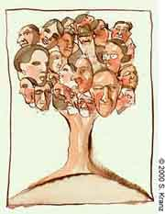
Question:

I've been asking this from everybody and I can't get an answer: Why do Jews exclude other people? My fiance's parents told me that for a Jew to marry a non-Jew and have children is worse than the Holocaust! I don't get it. Am I really that terrible? In a world with 6 billion people, what kind of G-d is the Jewish G-d, who chose a tiny percentage of the population of the world and left the rest without G-d's mercy?
I don't think I have to mention that I'm not a Jew myself, but I am in a relationship with a Jew, and I want to know more. I want to understand, because right now, I have big problems finding acceptance and respect for Judaism, which of course causes problems in our relationship. I could ask him, but I would rather ask a rabbi, since I expect you to have deeper knowledge than my boyfriend.
Hope to hear from you soon.

Answer:

I'm glad you were persistent in asking your question, and I'm glad you've given us a chance to answer.
First, please keep in mind that I didn't make any of the statements you are citing. Start reading fresh, like we've never discussed this before. Because, we haven't.
I'm sure you understand that every creature G-d has made on this planet wishes to survive. Not just each individual critter wants to go on living, but the mothers want to see their children survive and those children want to see their children survive and so on. In other words, each species wants to endure and survive.
We Jewish people also want to survive. We are a tiny portion of the 6 billion you mentioned. We've been around for almost four thousand years. At times, we made up more than 10% of the world. At other times, much less. Right now, we're less than a quarter of a percent.

The World Should
Want Us to Survive
Each people makes their contribution to humanity -- inventions, ideas, wisdom, music, art, culture. As a people, we've made many important contributions to the rest of the world. Such as monotheism, the value of human life, equality before the law, the concept of world peace. All these and many other ideas that are central to our society today find their source in the Bible and the other traditions of the Jewish people. Since Biblical times, we have made many more contributions to the societies in which we lived, whether in ethics, in philosophy, in medicine, in the sciences...you name it. So it would make sense that the other nations of the world, as well, would want us to survive.
Do we claim superiority? I don't think so. Christians and Muslims both attest to the truth of the Biblical account, where we were picked out by G-d to perform a mission -- to be a light unto the nations. We contend that G-d never changed His mind. And, as anyone can see, we've accomplished much of that mission. Most of the ethics we were charged to teach have been accepted by most of the world. Maybe they haven't put it all into action -- but they will, and we believe that time will come very soon.

We Don’t Exclude Others
Do we exclude others? Absolutely not. Any person who wishes to join the Jewish people and their holy mission is welcome, regardless of race, color, sex or family background. We only ask that they commit to keeping the rules G-d gave us, just as the Jewish people accepted those rules when they received the Torahat Mount Sinai some 3300 years ago. And if they opt not to join, we believe that the righteous people among the nations will share in the rewards of the time to come. I don't know of any other religion so liberal as to say such a thing: You don't have to join us, you don't have to do the things we do, just believe in one G-d and fulfill the basic requirements of every human being to society, and you're in.
So what's so terrible about us wanting to survive? Obviously, we aren't going to survive if we intermarry with everyone else and raise our kids as just a muddle of everything. Our only route to survival is for Jewish people to marry Jewish people and bring their kids up as good Jews.
Of course, if a girl from a non-Jewish family decides she wants to join the Jewish people, well, what's stopping her? But we don't push that sort of thing, because, first of all, we're not out to push our thing on others. You can be a righteous non-Jew and be loved by G-d, so why should we push you down a path you weren't born into? You may well resent it later on -- as often happens -- and that doesn't make for a good marriage. And, secondly, some people become Jewish just for the sake of marriage, and then once they're married, the whole thing is dropped. Which means we have to be a little scrutinous about accepting converts, to be sure they're doing this because they truly want to.
I hope this explains things a little for you. If you still can't swallow it, please write me back.
I wish you all the wonderful things your life has in store, not one should go missing.

Reprinted from this week’s email of Chabad.Org Magazine.

One Jew in Albania
By Rabbi Israel Meir Lau

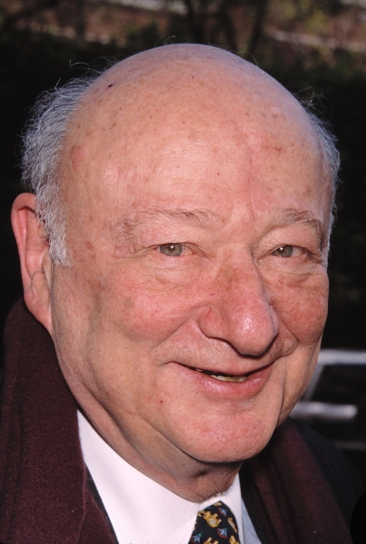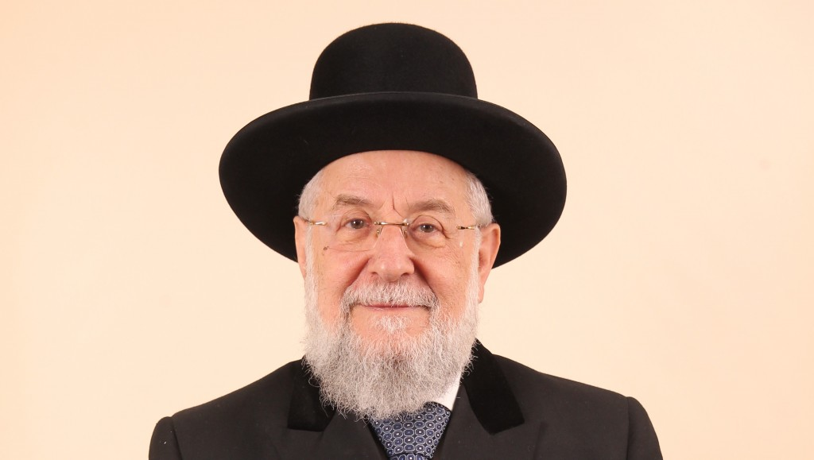
Mayor Ed Koch Rabbi Israel Meir Lau
"Those who endured the horrors of the camps are not the only Holocaust survivors. That group includes a wide range of Jews from all over the world. At the beginning of the 1980s, Ed Koch, mayor of New York City, invited me to his office. He is a warm Jew, sensitive and emotional, a great lover of Israel and the Jewish people.

Declared Himself Also to Be a Holocaust Survivor
“At our first meeting, he introduced himself to me and declared that he was also a Holocaust survivor. Out of politeness, I refrained from asking him what exactly he survived and where he had been during the Second World War. I wanted to give him a chance to tell his story himself. He said that he had been born in the Bronx and had lived his whole life in New York, but insisted that he was a real survivor. Smiling, I dared to ask how that could be- and Ed Koch began to explain.
“Years earlier, he had traveled to Germany for an educational trip. At one of the stops, the guide showed the group the globe that had sat on Hitler's desk. "It reminded me of Charlie Chaplain's movie about the great dictator. But unlike the one in Chaplain's movie," Koch recounted, "that big globe had lots of numbers written on it in black marker.

Europe Blackened with Numbers
“When the guide spun the globe, Europe blackened with numbers. Other continents had far fewer black marks. The guide explained that when World War II broke out, Hitler recorded the Jewish population of each country. After all, they represented his life's goal. Albania, for example, bore the number 1 for the single Jew living there. Our enemy decided that he would not rest as long as that one Jew from Albania, a total stranger to him, remained alive.
“The territory of the United States bore the number six million. [The population statistics are slightly inaccurate] That includes me," said Ed Koch with undisguised anger. "So I am also a Holocaust survivor-if the Allies hadn't stopped the Nazi beast, no doubt I would have been destroyed."

Learned an Important Lesson
“I shook his hand warmly and said, "Today I have learned an important lesson from you, and I will carry it home with me to Israel. I've heard that not all Jewish communities feel a connection to Holocaust Day. From now on, I'll tell them about the Jew born in New York who lived all his life in an American city, but who feels like a Holocaust survivor..."

Reprinted from the April 28, 2014 email of the Shehebar Sephardic Center. Excerpted from Rabbi Israel Meir Lau's book "Out of the Depths" (pages 241-242)

